Scenario Modelling and Database Implementation
CE205 Assignment 1 2017-18

Cieran Almond (1604959)

1. Choice of Entities, Attributes and Relationships
How you determined the entities to model, the attributes and the relationships between entities. Why you chose the entities you did.

- Identify four entities which you would like to model. One of them must be ‘camera’ and the others must be linked to ‘camera’ in some way. I chose Lens because every camera has a lens, and additional lenses are very popular, especially on DSLR cameras. So, in my opinion, its an obvious entity that will be related to camera. I chose memory card because every camera uses a memory card to save pictures onto, mainly for removable storage of pictures, whether it be a digital camera or DSLR camera, and so again, would relate to the camera entity. Finally I chose manufacturer because every product has a manufacturer, so I could relate all the entities to the manufacturer entity. I will be using lens_name, manufacturer_name and memory_card_name as primary keys to link the entities to the Camera.

Camera(camera_name, camera_brand, camera_make, camera_price, camera_stock, camera_megapixel);

Len (lense_name, lense_make, lense_size, lense_price);

Manufacturer(manufacturer_name, manufacturer_address, manufacturer_phone, manufacturer_registration, manufacturer_website);

Memory_card(memory_card_name, memory_card_space, memory_card_brand, memory_write_speed, memory_read_speed);
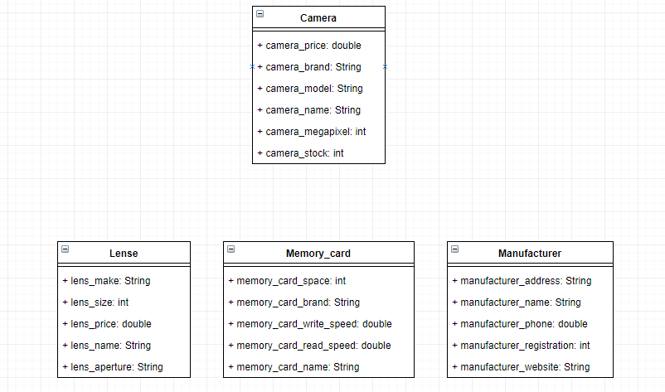

2. Conversion of Model to 3NF

My diagram is already in third normal form. Firstly, the table fits the condition for 1NF since there are no duplicate entries, and each table has a primary key (memory_name, lens_name, manufacturer_name and camera_model. There are no subsets of data that apply to multiple rows, therefore it fulfils 2NF as well. Finally, all of the colums are dependent on the primary key, eliminating the functional dependencies on non-key fields and so the table is therefore already in 3NF. My table uses relations between camera, manufacturer, memory card and lens, and so through these relations, has a few null attributes in the Camera table because of these keys. This is an inefficient process that in hindsight I would change in the future, as the purpose of putting tables into 3NF is to reduce data redundency and maintain integrity to the database.

See table below:

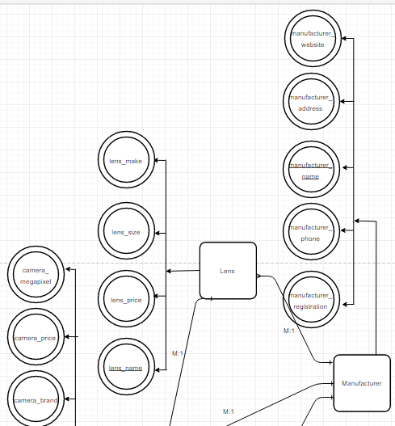

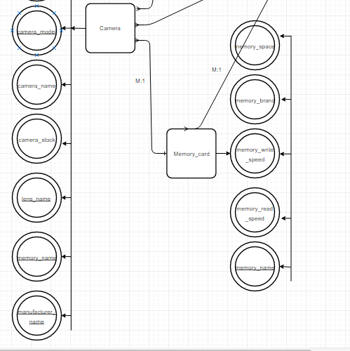

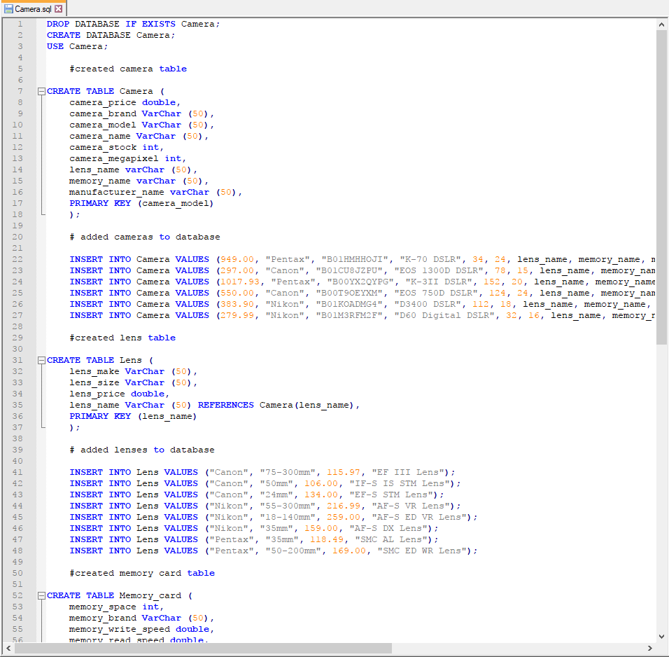
3. Sample Queries and Output

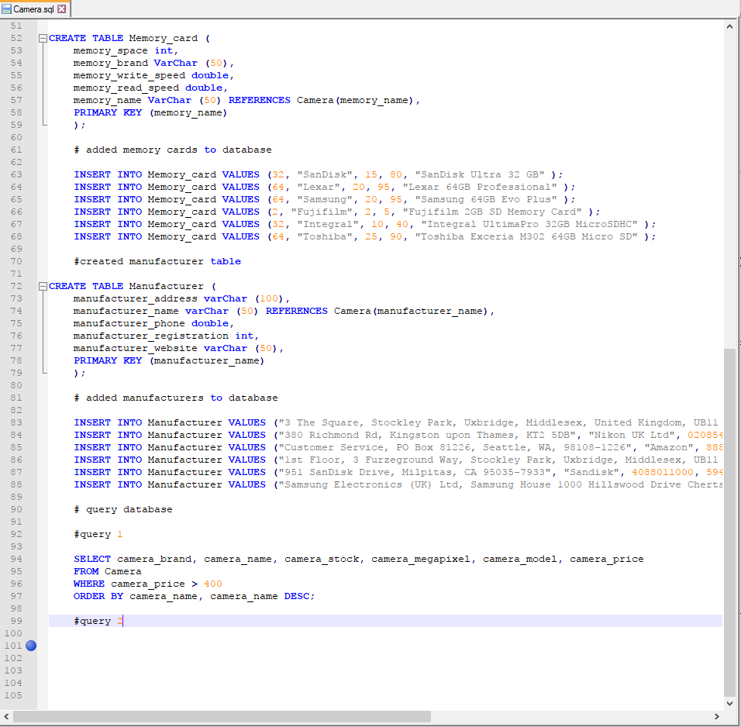

Example of the database being created, and adding values to them. The database was written in Notepad++ and was executed using a .bat file to generate a log textpad, as seen below. This screenshot shows the tables being created and the data being successfully entered into the database.

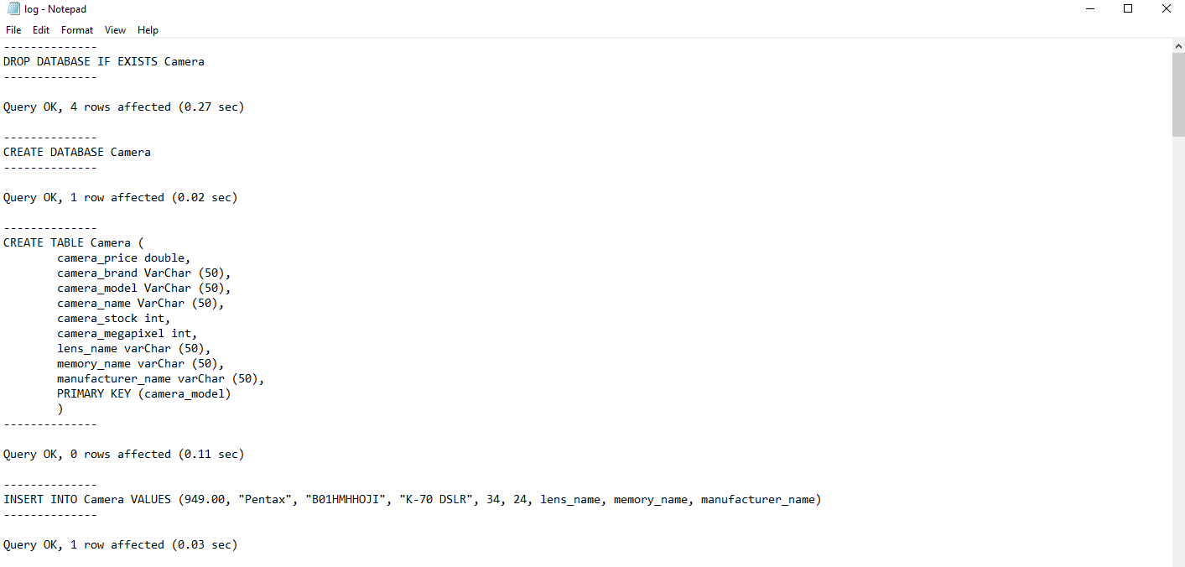

SQL queries:

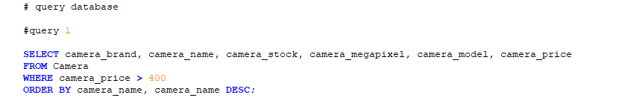
- This query I chose to demonstrate simple select searches on the camera table, given the condition of the price of the cameras and to sort it by camera name in decending order.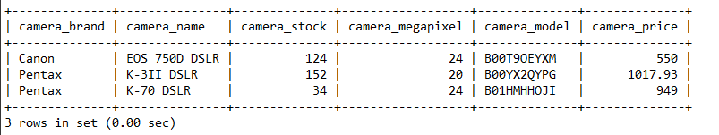

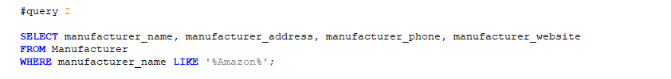
- This query I chose to demonstrate sorting of attributes by searching for a specific string in this query, just to demonstrate how to access manufacturer data from the database.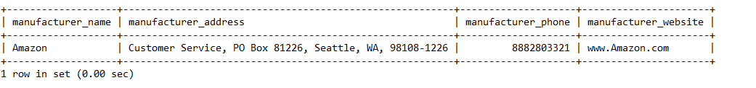
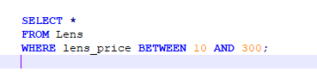

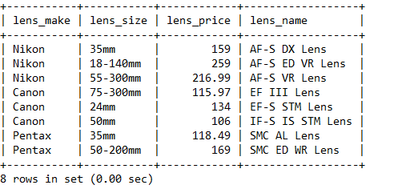
- This query I chose because it demonstrates how to query a set of numberical data providing there is condition of price between 10 and 300, returning data between those values.

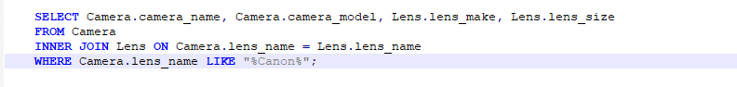
- I chose this query to demonstrate that the keys work, and that all the database is interlinked via foreign keys, the purpose of the inner join is to link Camera and Lens together. The final condition being that it searches a particular string.

